Creating And Populating a Database in MySQL with phpMyAdmin.

First, start phpMyAdmin by navigating to localhost/phpMyAdmin. You should see the screen below.

Type in the name of the new database “magazines”.
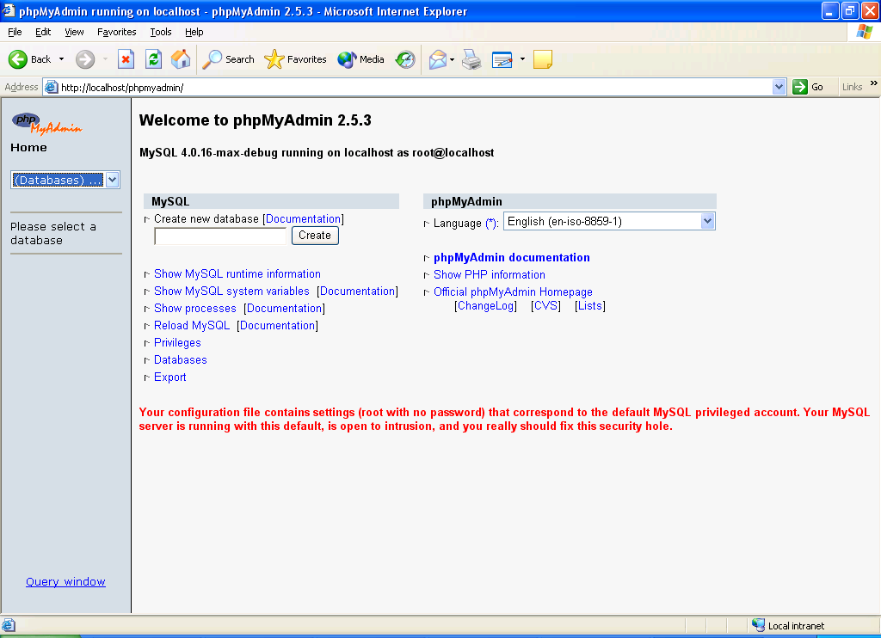

After you press on create you are taken to the next screen, below. Type in the name of the table for your database (“first”), and the number of fields required (“4”). Click on Go.
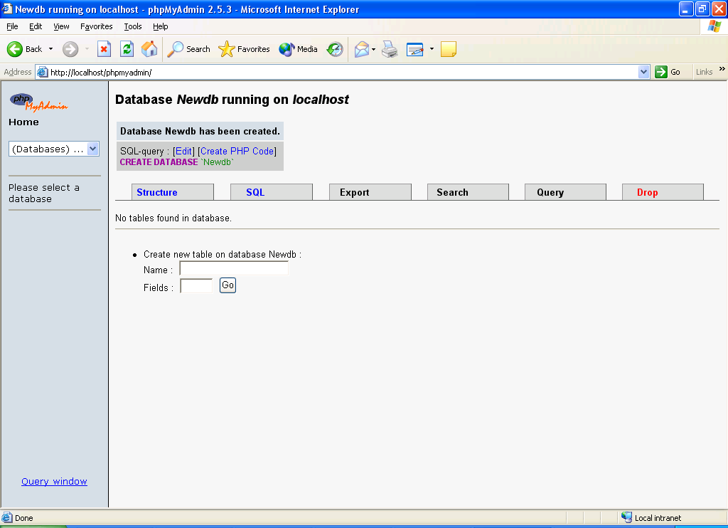

Now type the names of the fields and choose their types (enter the following fields and types: title – text, pubdate – date, volume – int, edition – int). Note dates in US format.
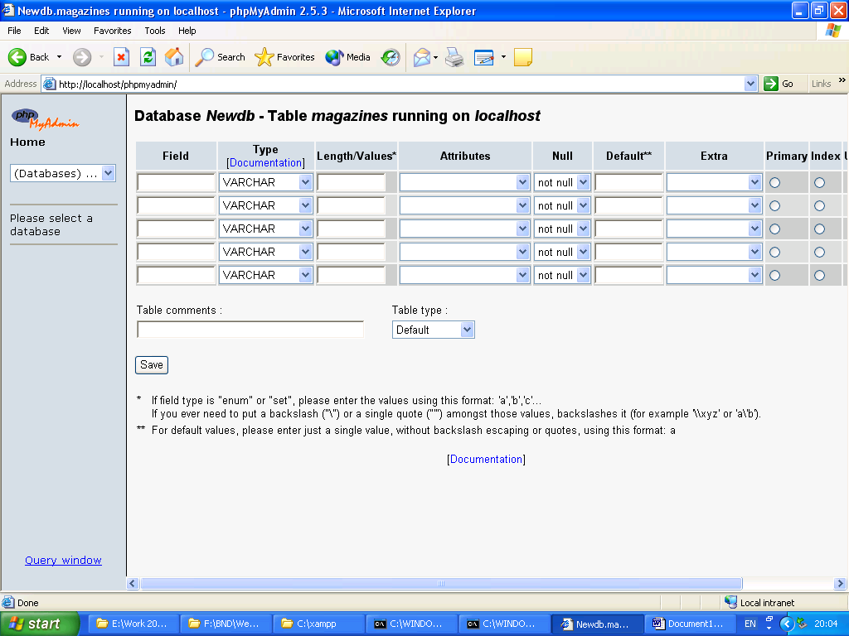

Click on save, this will take you to the next screen, check all the details are correct and then click on insert
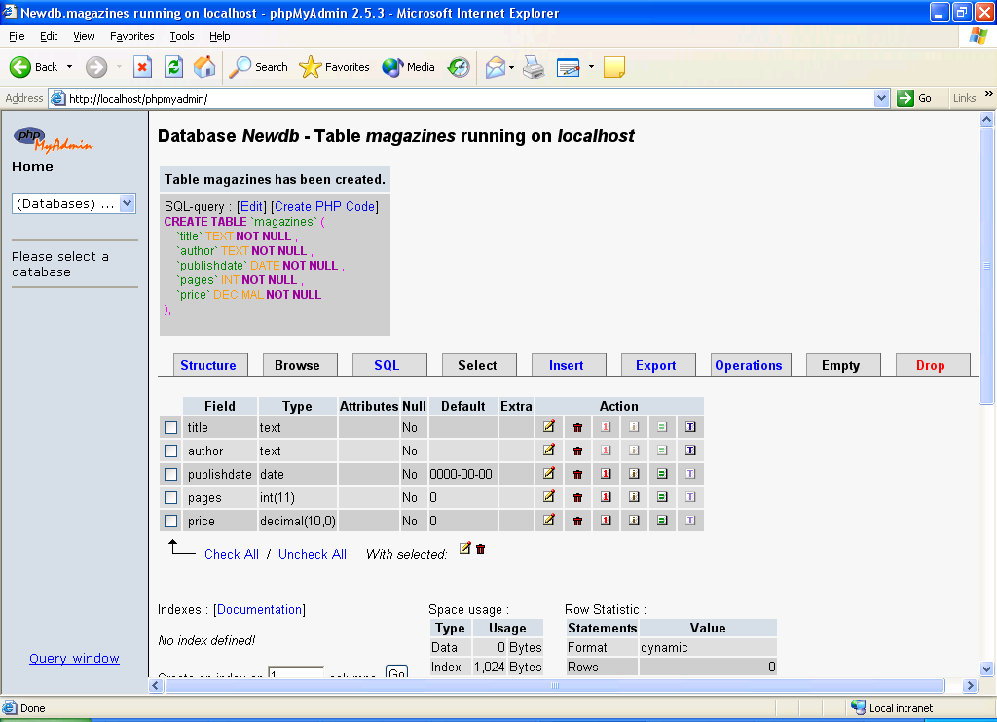

This takes you to the next screen where you can enter the information required in the table. Enter it in the required fields and select the ‘insert another new row’ radio button to continue entering records. Then click on go.
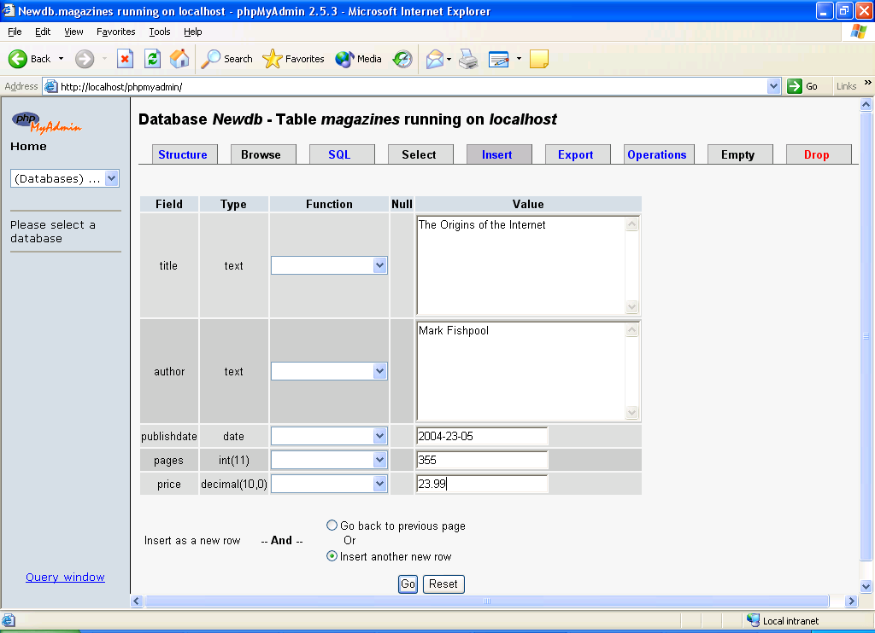

Enter the details of the following records:

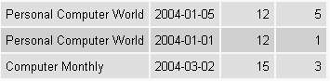

When all the records are entered, click on browse and you will be able to see all the records. Also notice it has created the SQL required to retrieve all the records.
